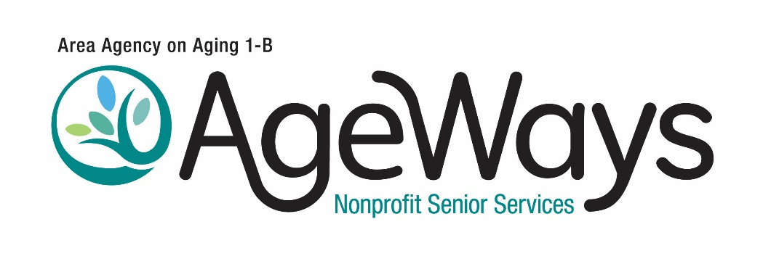
Senior center bulleting/newsletter content

Figuring out what kind of care you need whether for now or in the future can be confusing and overwhelming. Older adults and their caregivers often spend hours on the phone and on websites trying to understand what is available to them.
A new person-centered counseling program offered by AgeWays Nonprofit Senior Services aims to make it easier to navigate services and resources tailored to the immediate and long-term care needs of older adults, adults with disabilities, and family caregivers.
Funded by the Michigan Department of Health and Human Services, MI Options counselingis free of charge.
MI Options includes a 90-minute session with a trained counselor who partners with individuals to explore the options particular to their needs, whether that’s housekeeping or personal care. After helping them develop an action plan, counselors will follow up regularly to help them meet their goals.
Counseling appointments can take place by phone,via video call, or in person.
To access MI Options, call the statewide call center at 800-803-7174 from 8 a.m. to 8 p.m. weekdays, or AgeWays at 248-262-5488 from 8:30 a.m. to 4:30 p.m. weekdays.

